Testing Document

Submitted by: Karthik Somanahalli Muralidhara

UTA ID: 1001520125

DB NAME: karthikpetstore

XAMPP HOME SCREEN

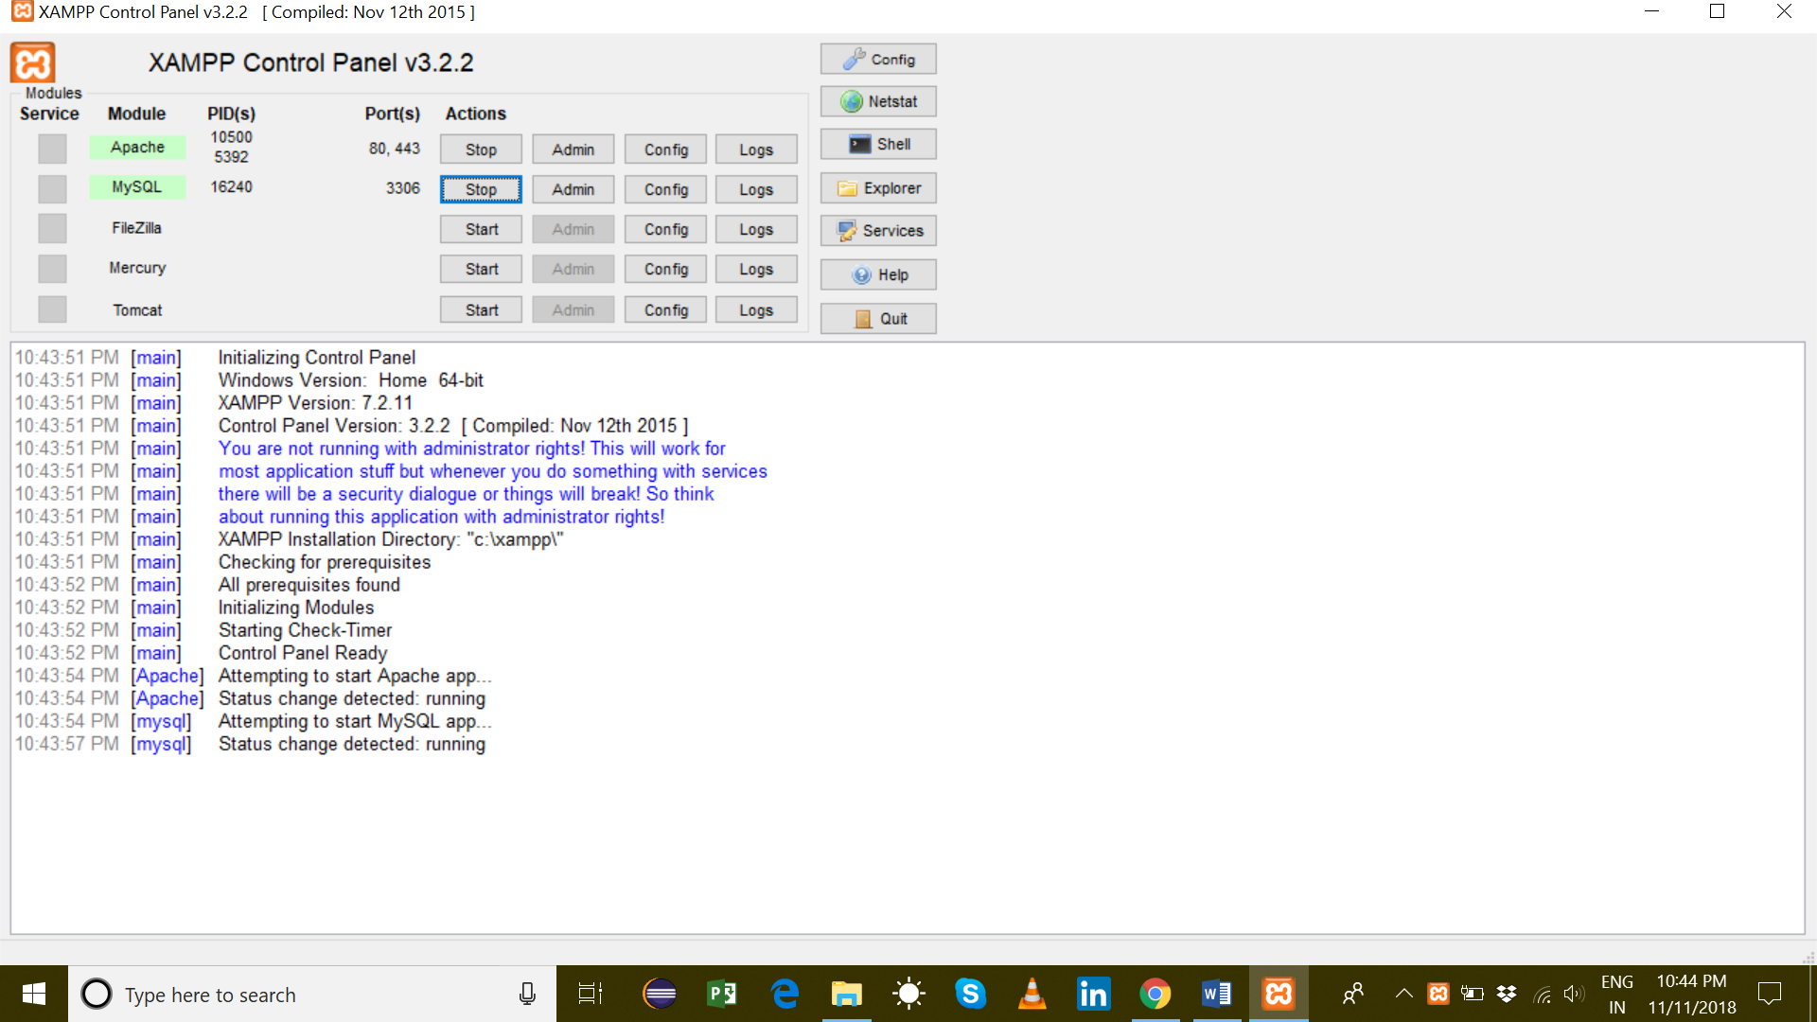

Business Table

SELECT\* FROM Business

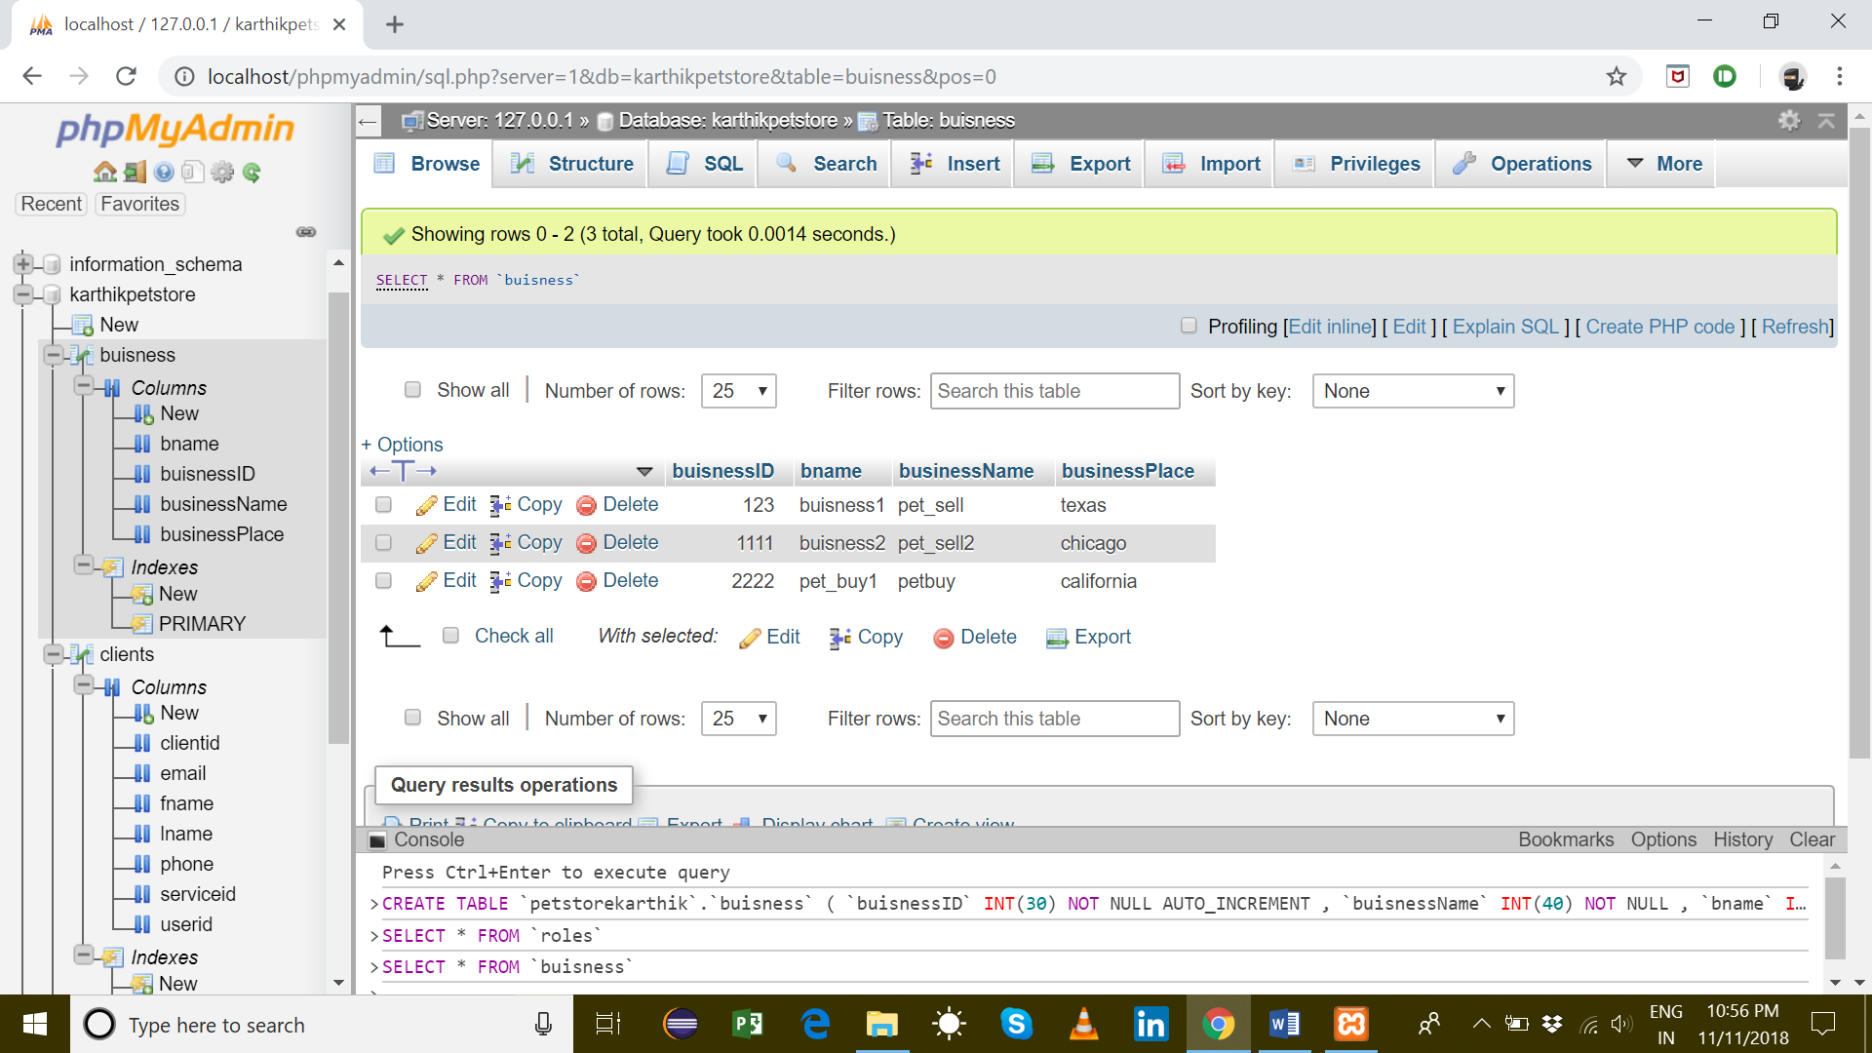

Services Page

SELECT\* FROM services

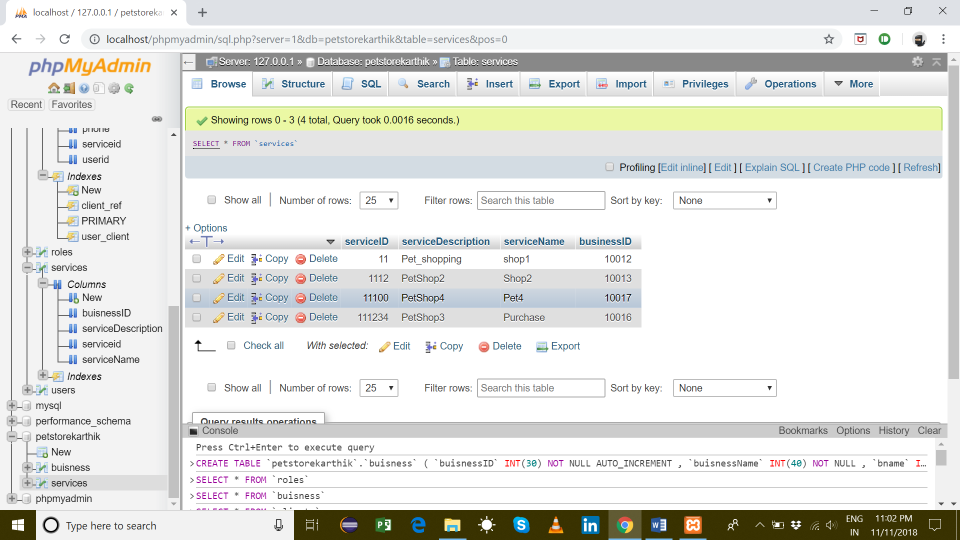

Roles Page

Services\* from roles

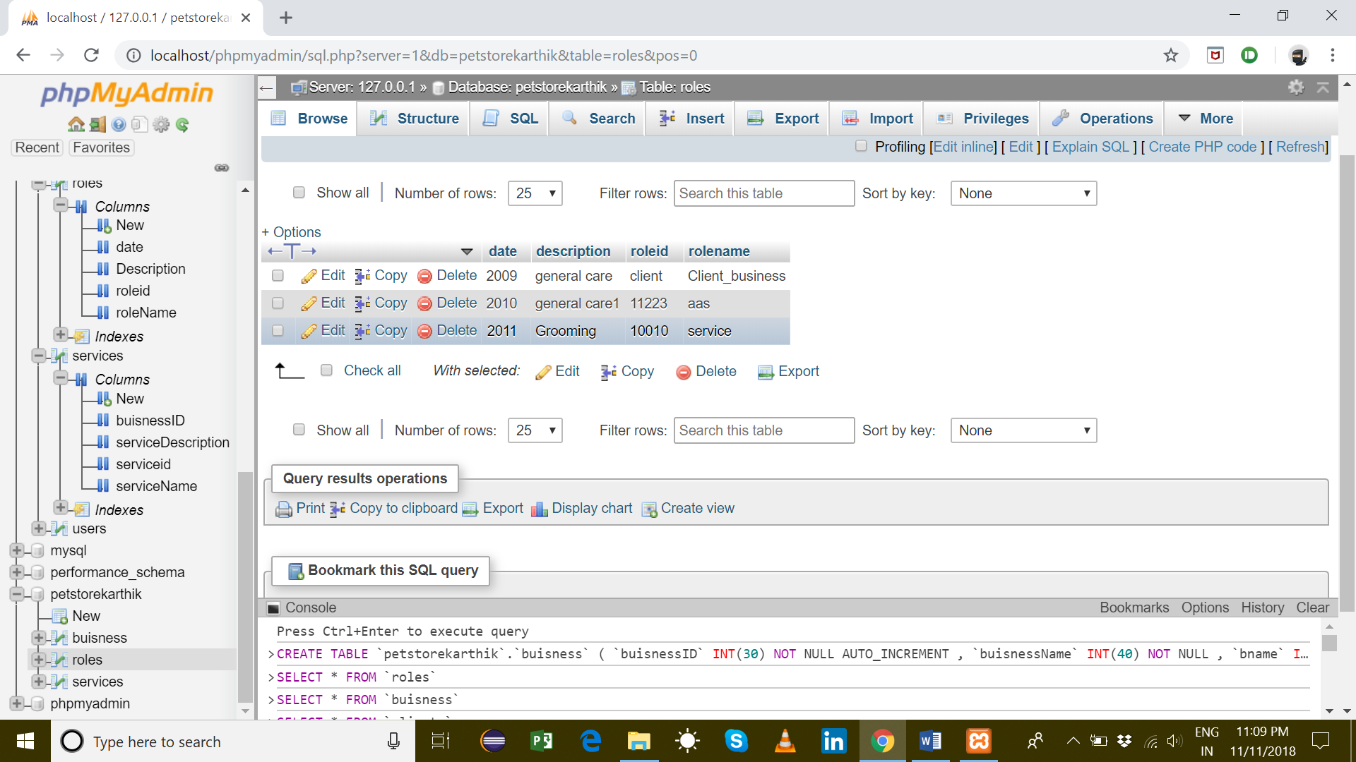

Clients Page

Select\* from Clients

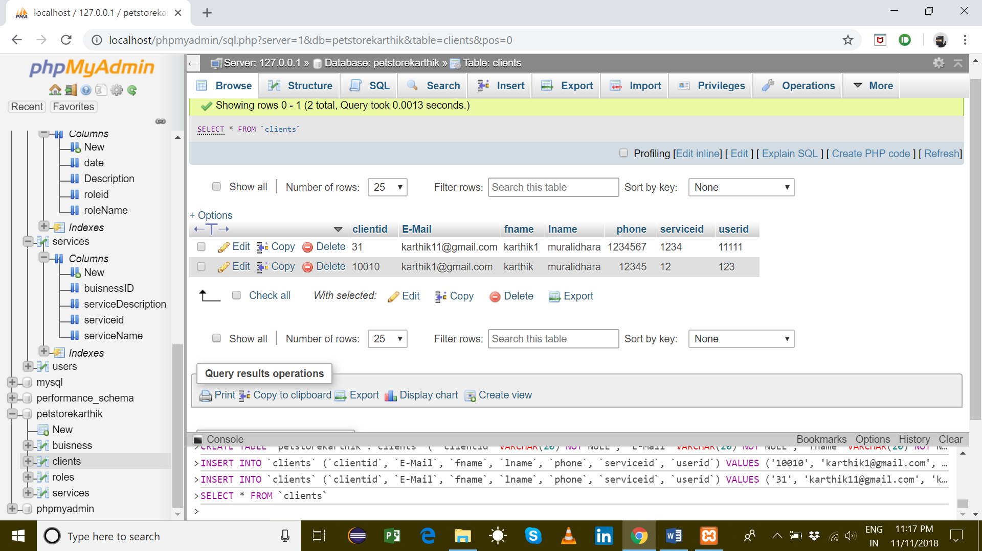

USERS TABLE:

Select\* from Users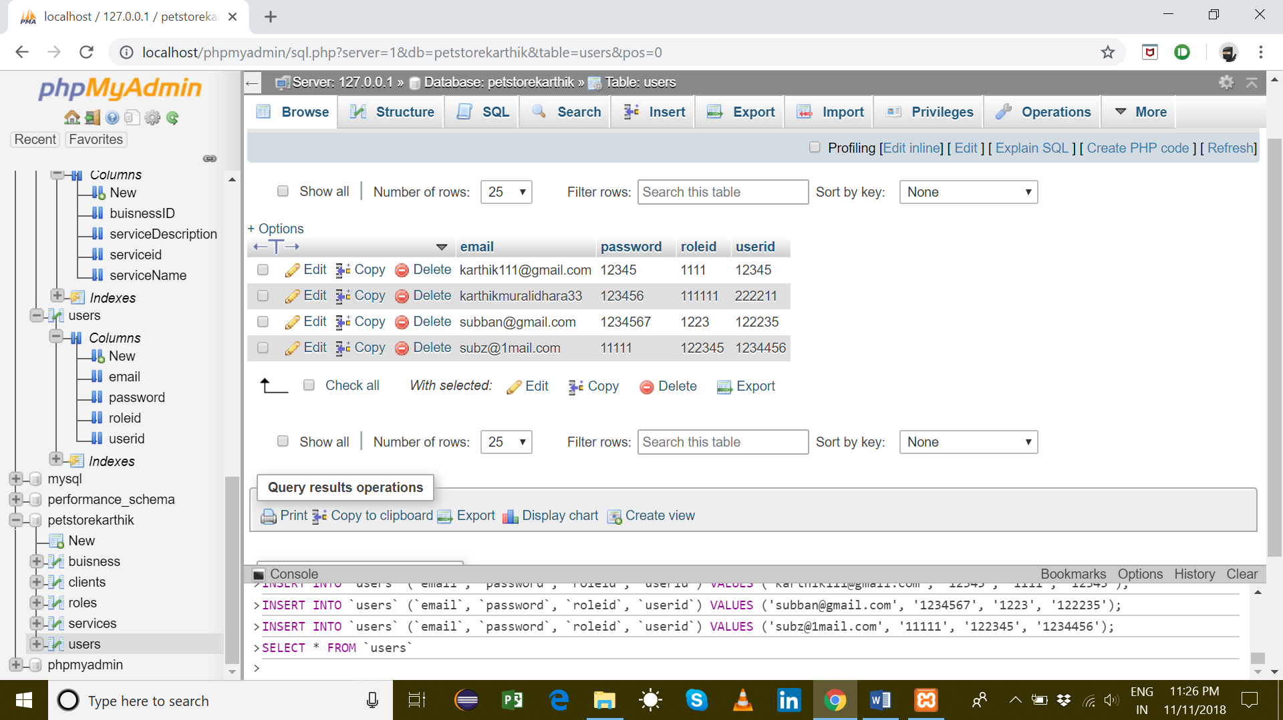

The above screenshots are for the respective SQL queries and their tables.

Sample SQL

